**RIVERSIDE SECONDARY SCHOOL**

**Subject Combination Option User Guide for Students (Express)**

**URL: https://riverside.schoolhub.sg**

## Log in

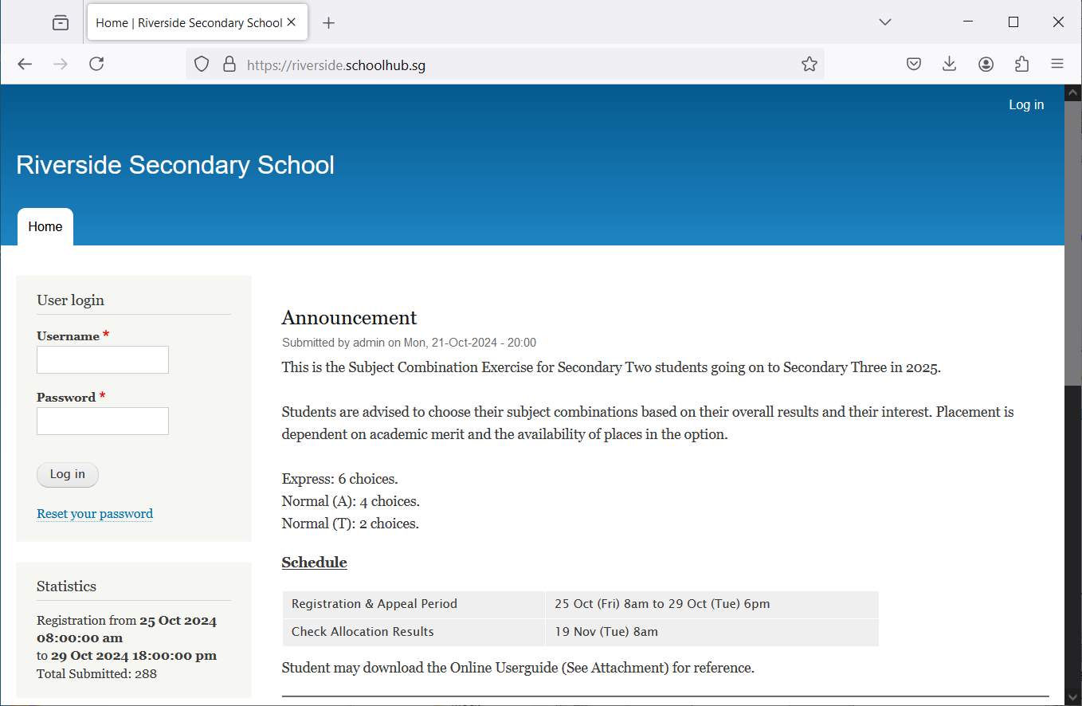

Steps

* Enter Username
* Enter Password
* Click on Log in button

## Main Menu

Upon Successful login, you will see the main menu

Update your Account

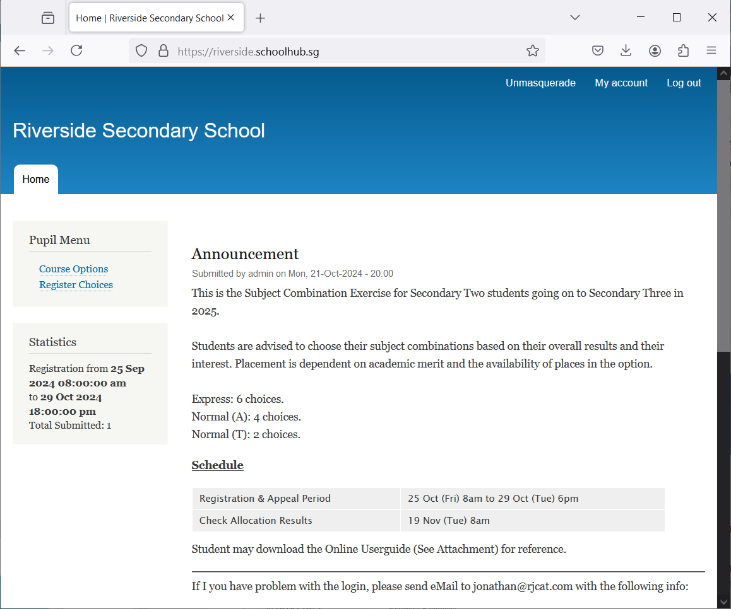

View all Subject Combinations

Update your choices

All Announcements will be posted here.

Send eMail if you have issue

## Update User Account

This is Optional. You may change your password and update your eMail before you proceed to your Subject Combination choices.

Click My Account

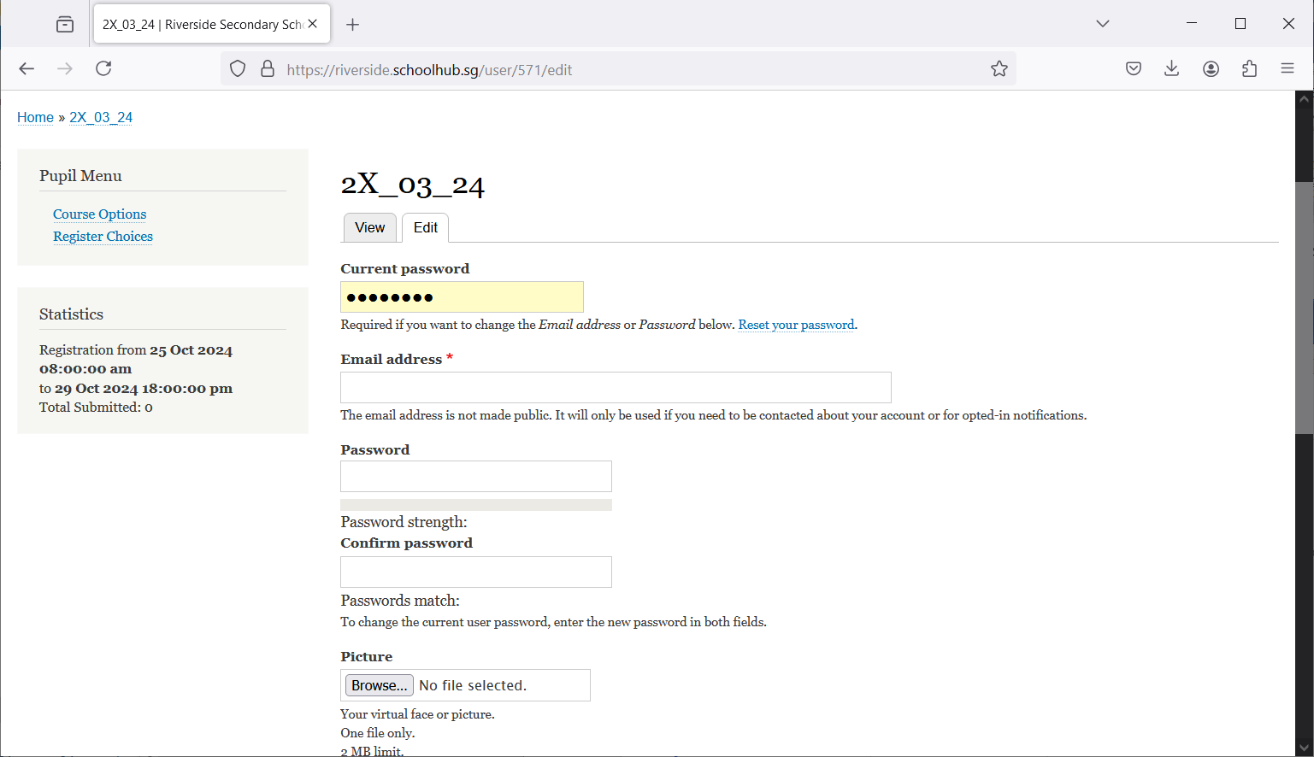

Steps

* Enter current password
* Update eMail Address
* Enter New Password (leave blank if you want to retain current password)
* Click on Save button

## View Course Options

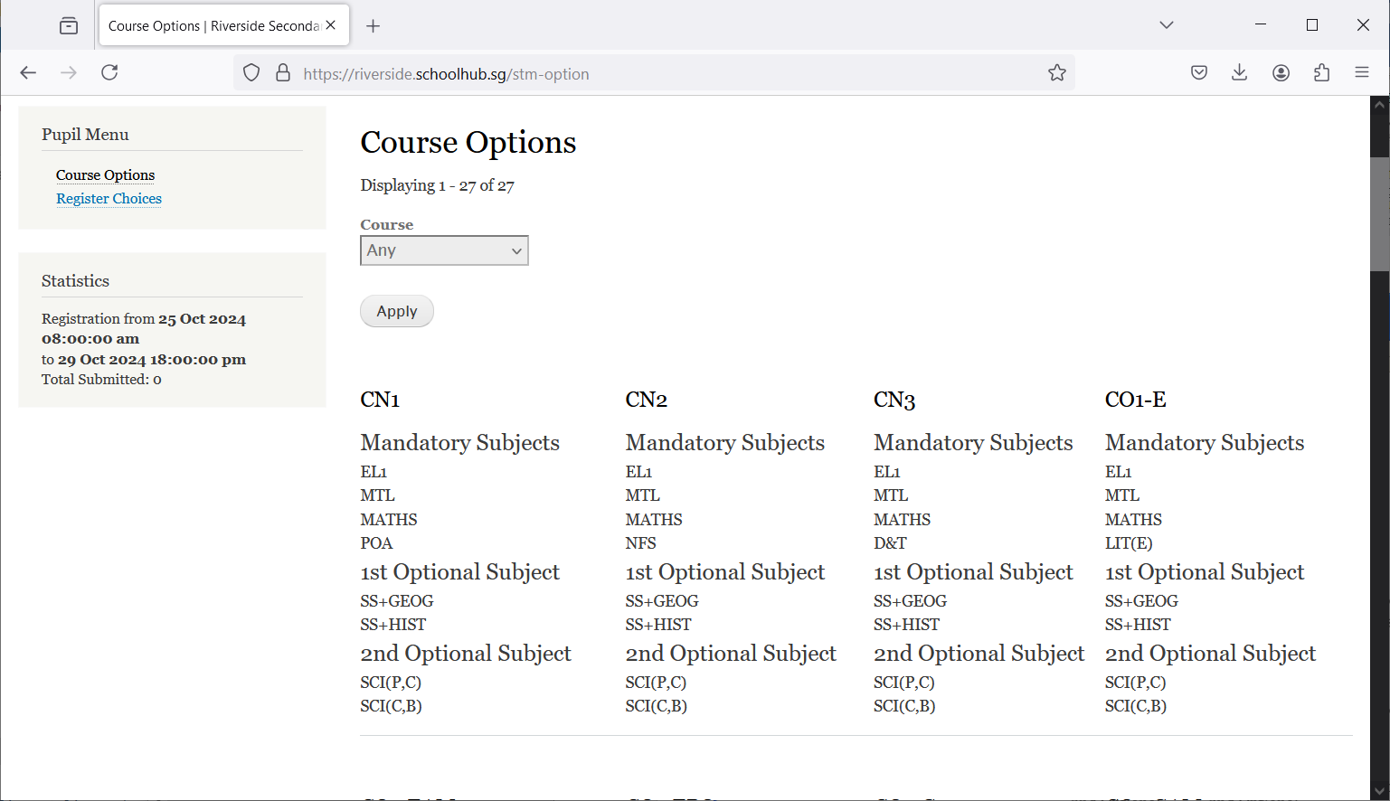

Click Course Options

## Registration of Choices

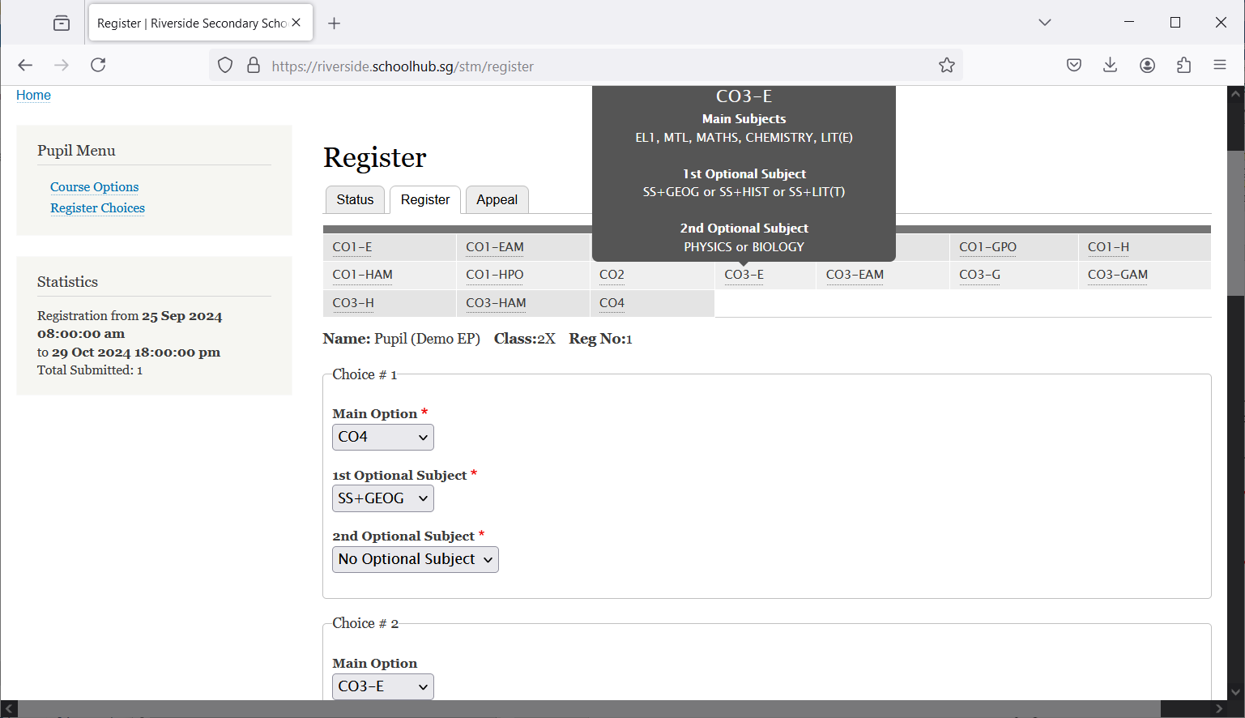

Mouse-Over to view Subjects in the option

These are the list of Options you may choose from

Click Register Choices

Enter all your choices

Steps

* Click on Student Option
* Update Your choices

## 

Tick this Box

Steps

* Click Submit at end of screen

Note:

You may change your choices any time before the closing date.

## Print Confirmation Slip

Once you have Submit Successfully, you may proceed to Print the Confirmation Slip.

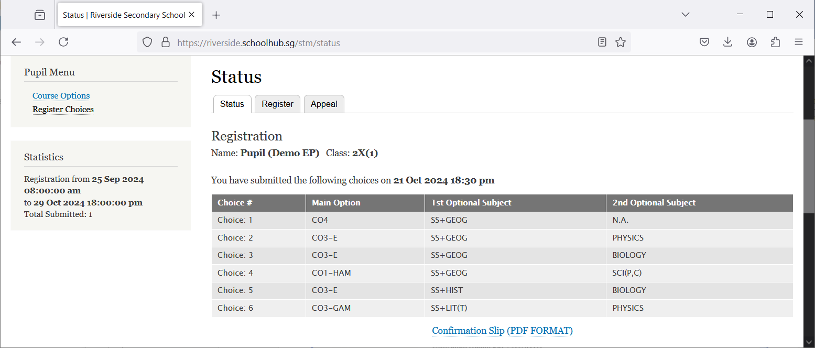

Print Confirmation Slip

Steps

* Click on Print Confirmation Slip (PDF Format)
* The hard copy confirmation slip must be signed and filled in with a contact number before submitting to General Office

**Sample Confirmation Slip**

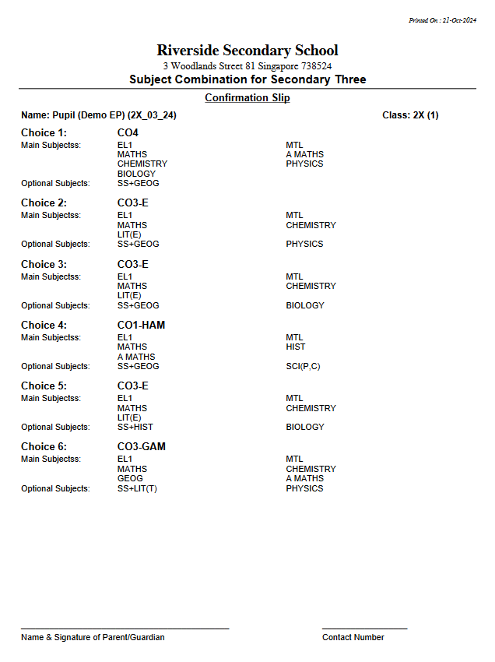

## Appeal

If you prefer another option which has not been offer to you, you may appeal for it here.

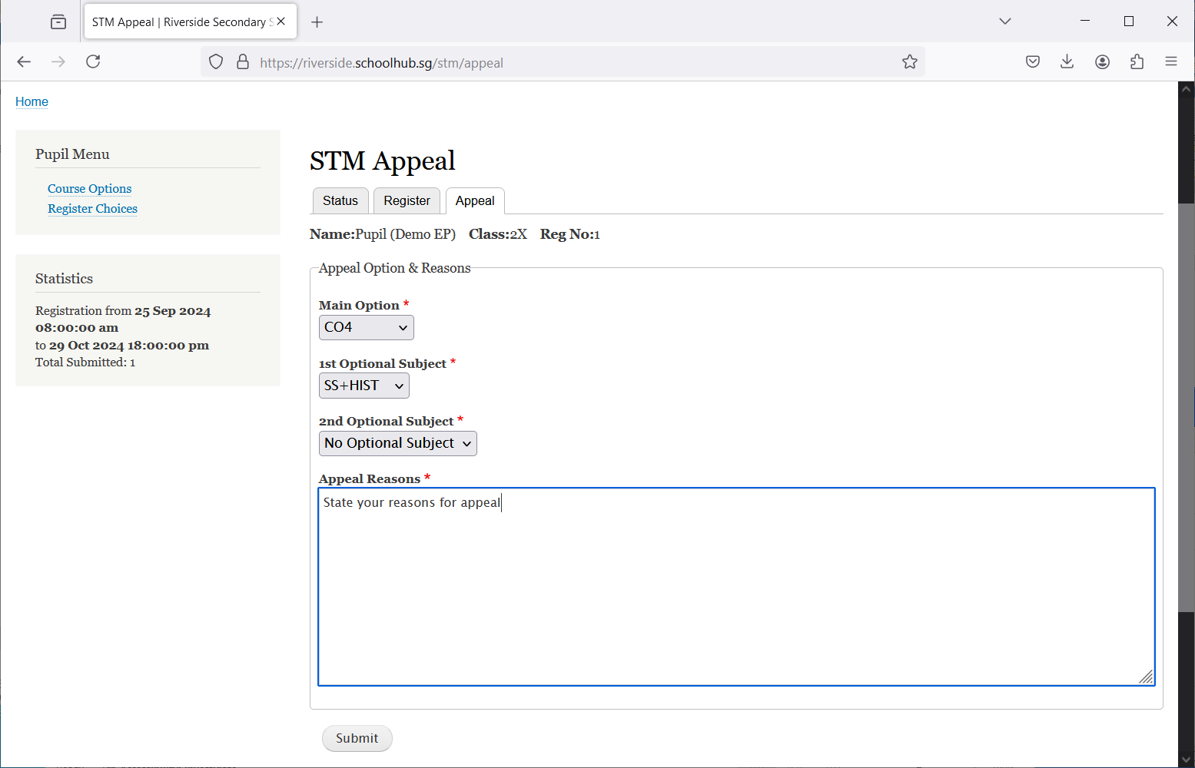

Steps

* Click on Appeal Tab
* Enter your Appeal, if any
* Click Submit at end of screen

## Print Appeal Slip

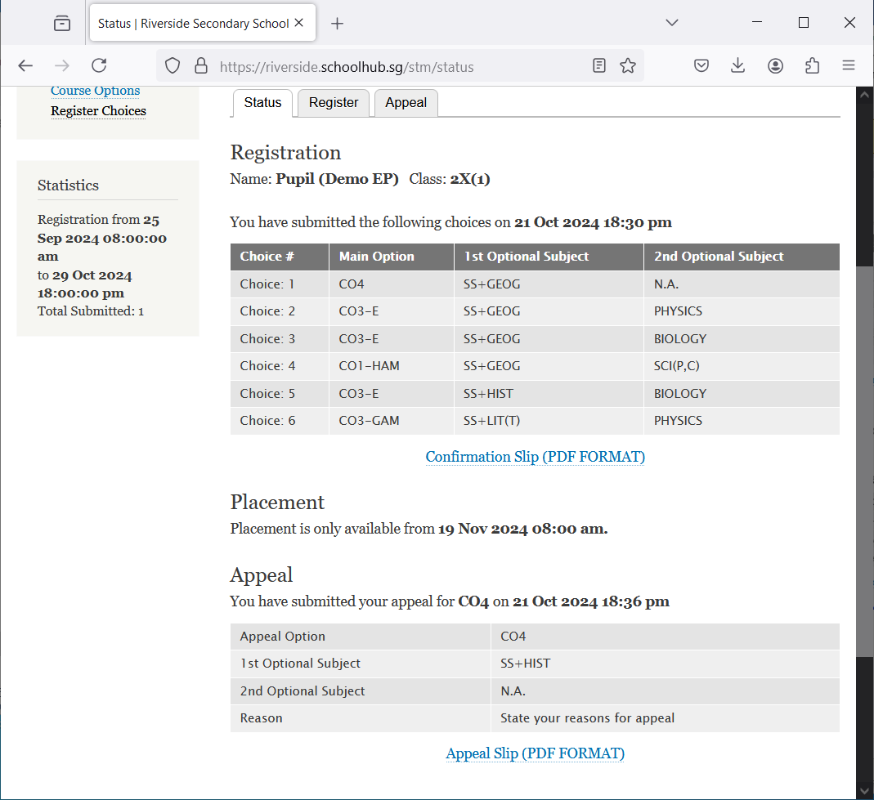

## Sample Appeal Slip

