Riverside Secondary School
Sec 2 Subject Combination Exercise

URL : https://riverside.schoolhub.sg

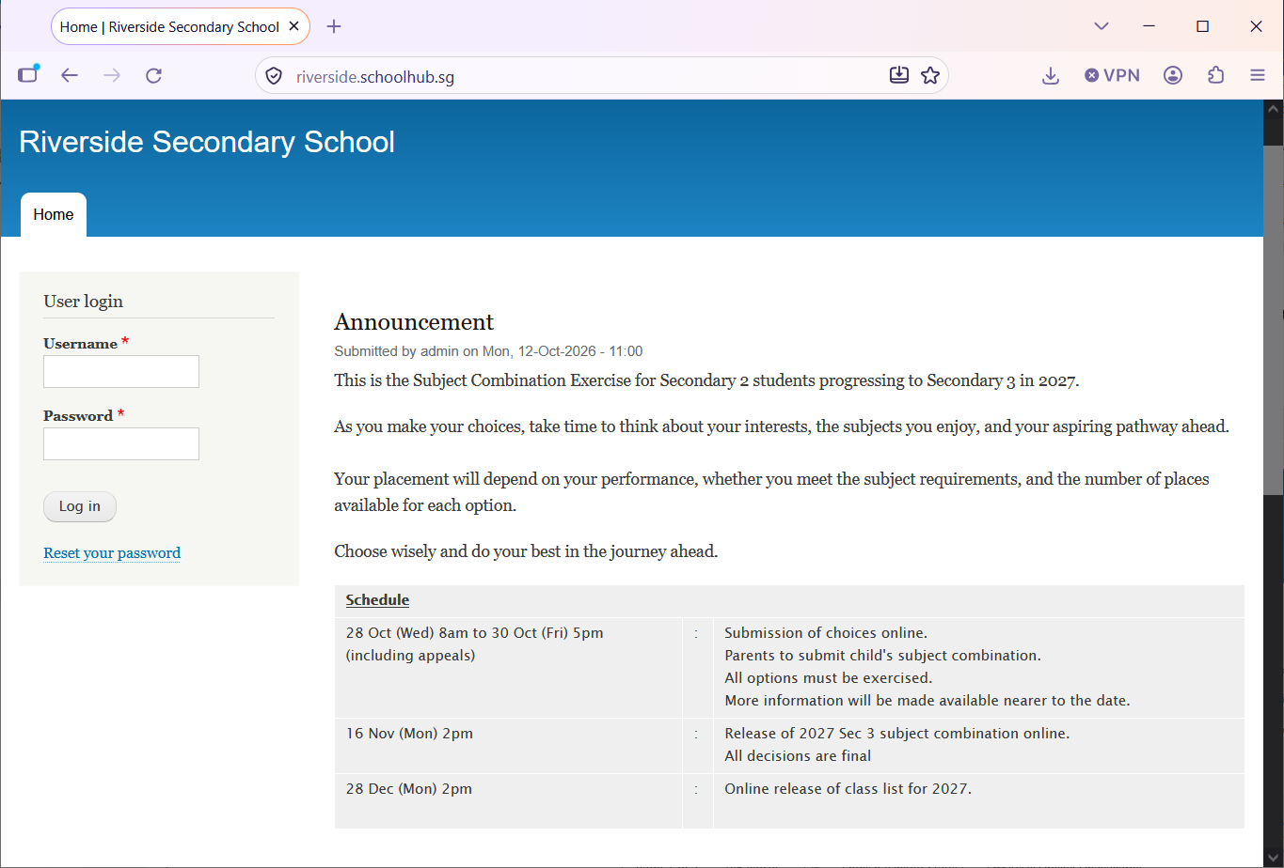

Steps
- Enter Username
- Enter Password
- Click Login

Register Choices

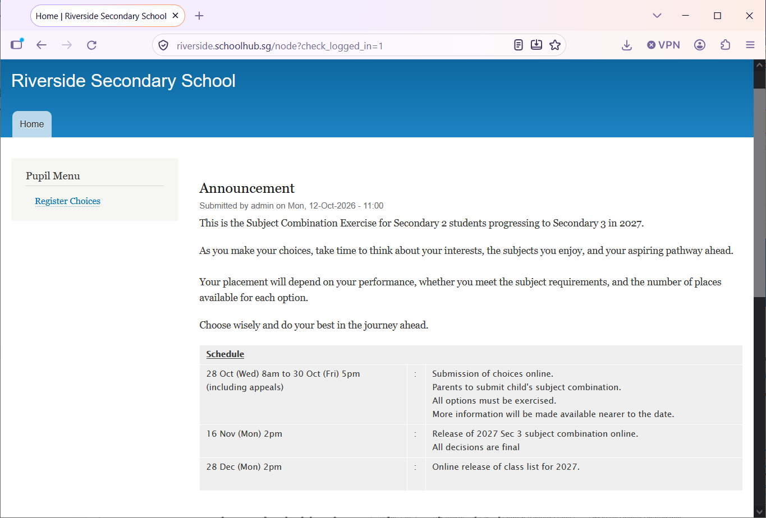

Steps
- Click Register Choices

The subjects are divided into different categories:
- EL - Compulsory
- MT - Compulsory
- MATH - Compulsory
- C/HUMANITIES
- SCIENCE or CO (Bundle)
- OTHERS
You will need to rank all the subjects within each category. Please note that only subjects offered to you will be available for you to rank. For categories with only ONE Subject (Compulsory), it will be automatically rank 1.

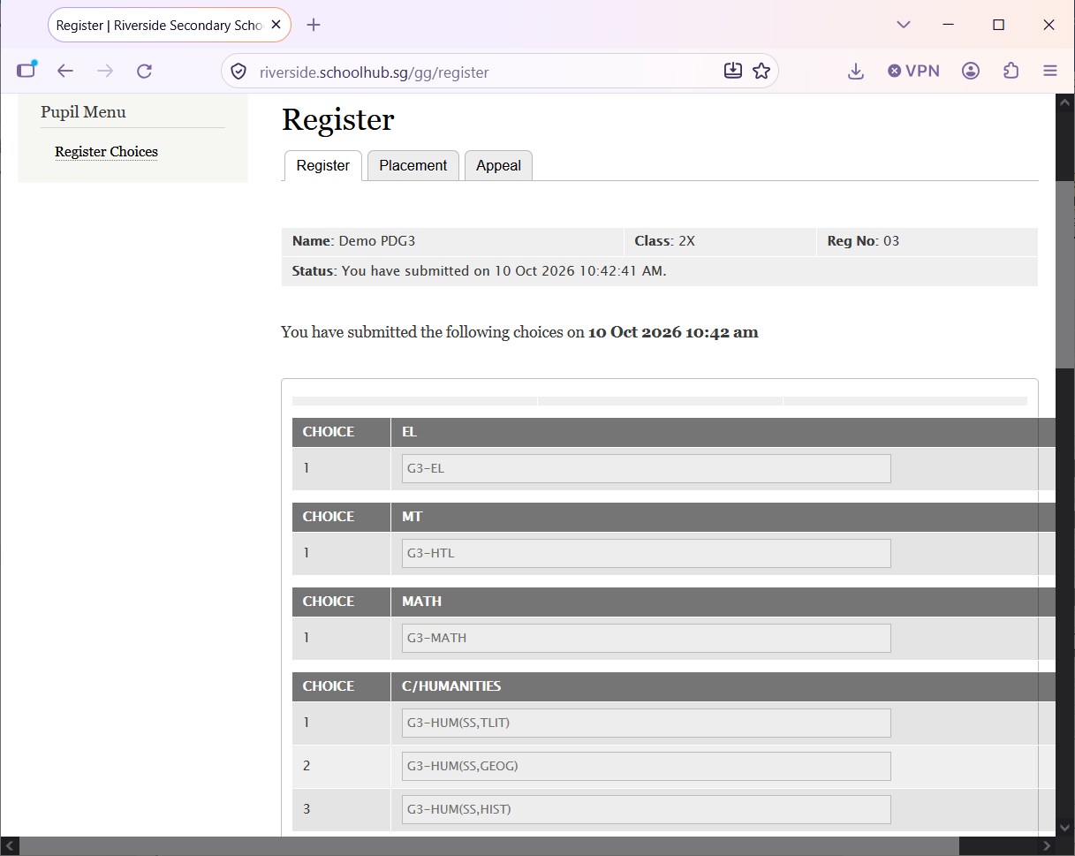
Hold and Drag to change your choices (within the RED box).
for example:
Change G3-SS-Hist to 1st choice
Change G3-SS+Geog to 2nd Choice
1st Choice = G3-SS+HIST
2nd Choice = G3-SS+GEOG

After changes:

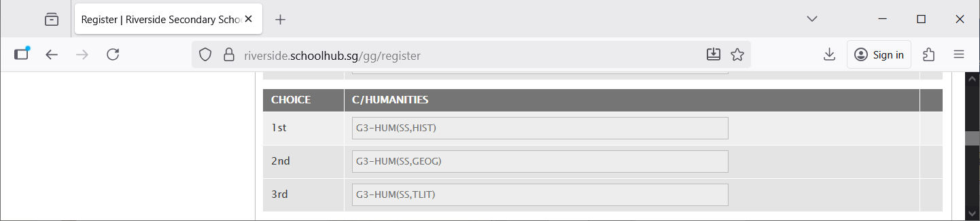

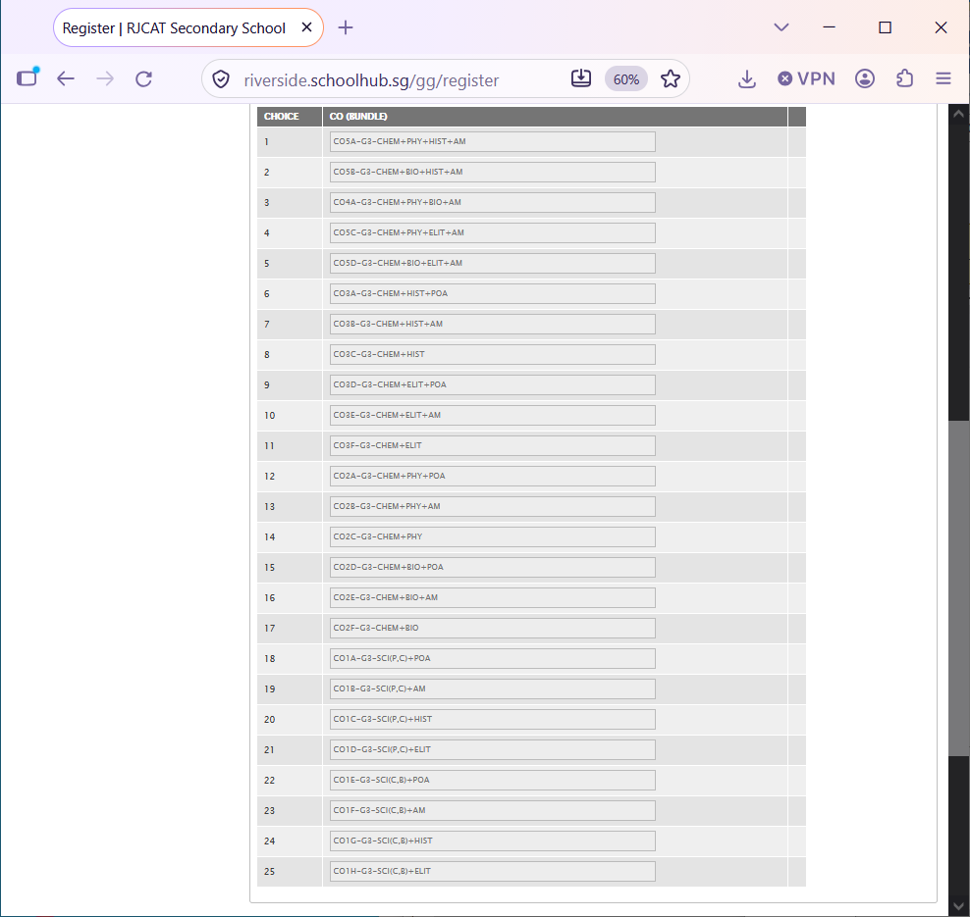

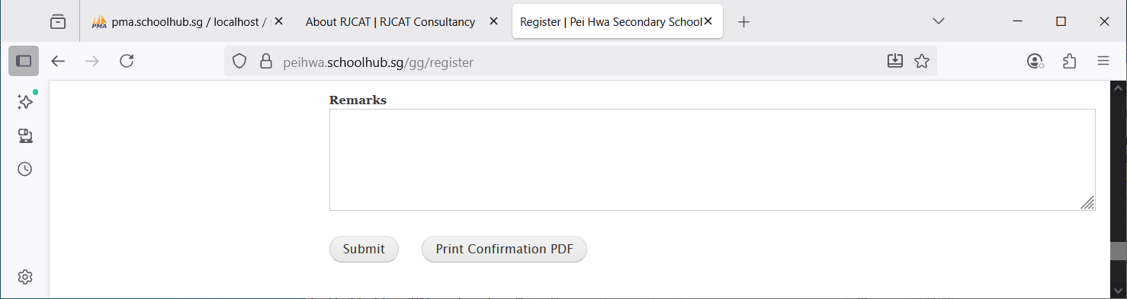
Click Submit to save your choices. You may change them before the closing date.
Click Print Confirmation PDF to get a copy of the PDF for your reference.
Enter any remark you wish to communicate with your teacher

Sample Confirmation Slip

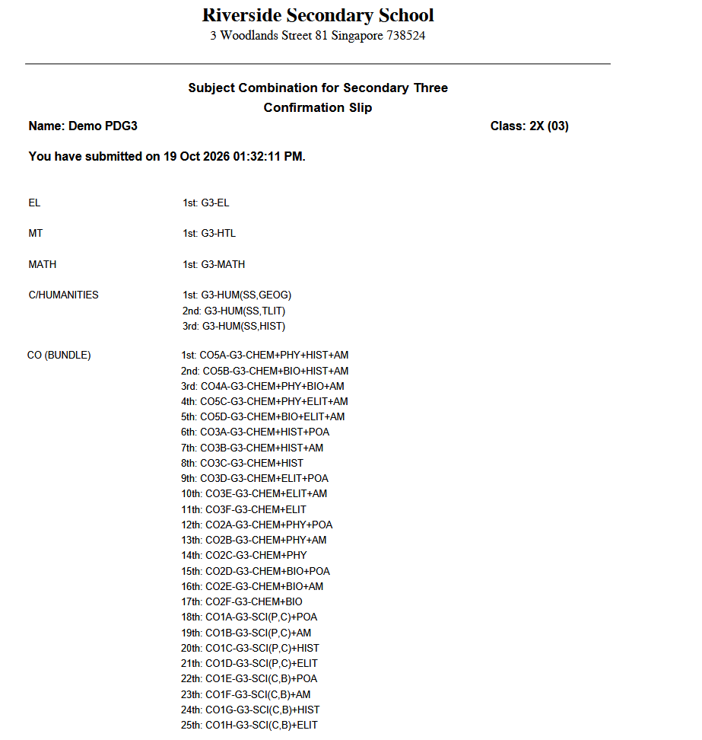

Appeals

You may appeal for a MAX of 4 Subjects.

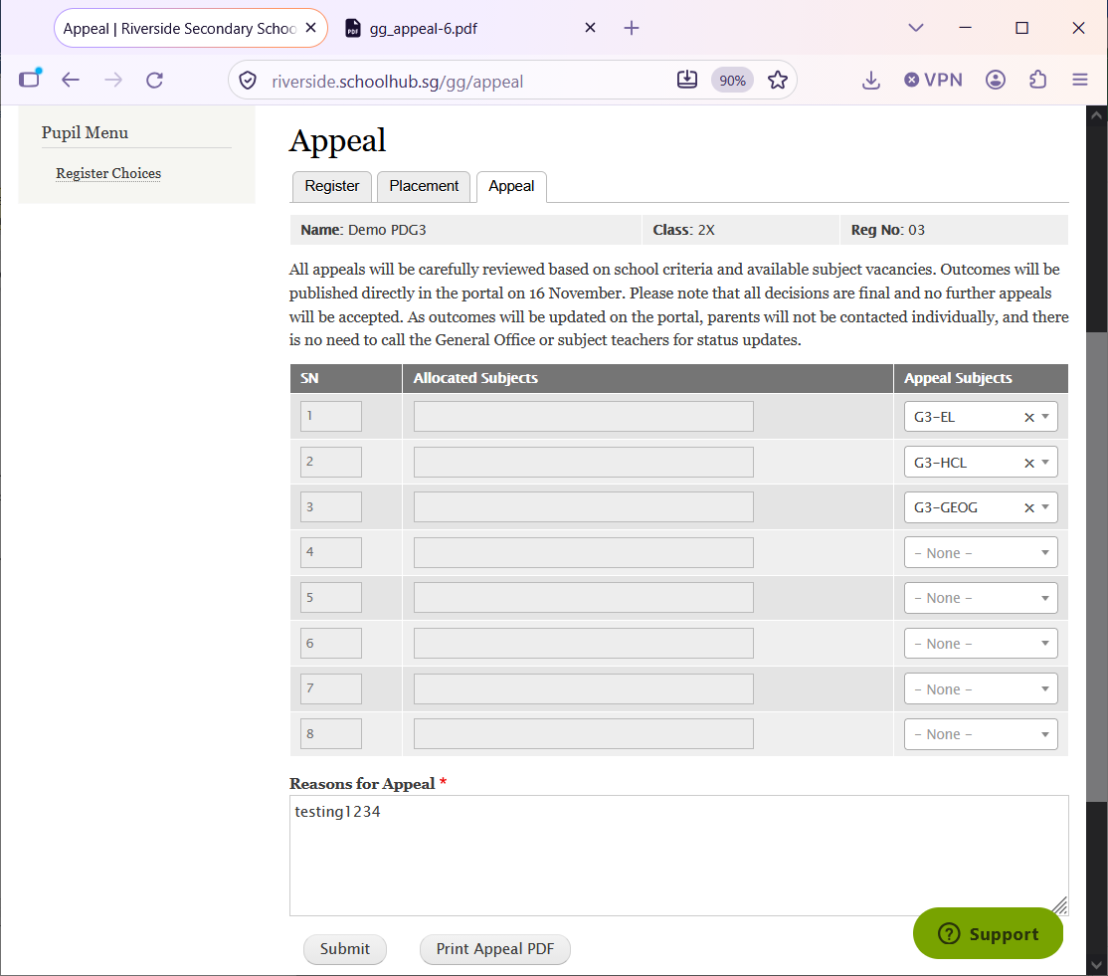
Indicate reasons for the Appeal
Enter Subject to Appeal
You may print a copy for your reference

